**Attendance System Using Face Recognition**

Prof. S.S.Vyavahare, Aakash Dabhade, Prathamesh Koli, Pratik Aher

Assistant Professor, Student, Student, Student

**Artificial Intelligence and Data Science  
Zeal College of Engineering and Research, Pune,Maharashtra, India**

---------------------------------------------------------------------***---------------------------------------------------------------------

**Abstract -** This research paper presents an attendance system that utilizes face recognition technology to automate and streamline the process of taking attendance. The proposed system consists of a database of enrolled students and a camera system that captures images of students entering a classroom. The captured images are then compared with the images stored in the database to identify the students and mark their attendance.

The system uses deep learning algorithms and computer vision techniques to recognize the faces of the students, even under varying lighting conditions, poses, and facial expressions. The system also includes a user-friendly interface for teachers to manage the enrollment of students and monitor their attendance records.

The system's accuracy and efficiency were evaluated through a series of experiments, which demonstrated that the proposed system achieved high accuracy in recognizing the faces of enrolled students and accurately marking their attendance.

Overall, this research paper presents a novel attendance system that addresses the limitations of traditional attendance methods and provides a more efficient and reliable solution using face recognition technology

**Keywords - Attendance system, Automated Attendance, Image Processing, Face detection, Face matching, Face recognition.**

**1.INTRODUCTION**

Face recognition is a computer technology that enables the identification and verification of an individual's identity by analyzing and comparing facial features captured in digital images or videos. It has emerged as a rapidly growing field of research in computer vision, pattern recognition, and artificial intelligence.

In recent years, face recognition has gained increasing attention due to its wide range of applications, including security and surveillance, law enforcement, human-computer interaction, and personal identification. The technology has proven to be effective in identifying suspects in criminal investigations, tracking individuals in public spaces, and enabling seamless access control to secure facilities.

This research paper aims to explore the current state of the art in face recognition technology, including its underlying principles, key techniques, and recent advancements. Additionally, this paper will discuss the ethical and privacy concerns associated with the use of face recognition and the need for responsible development and deployment of this technology.

Overall, this paper seeks to contribute to the growing body of literature on face recognition and to provide a comprehensive overview of its potential applications, challenges, and future directions.

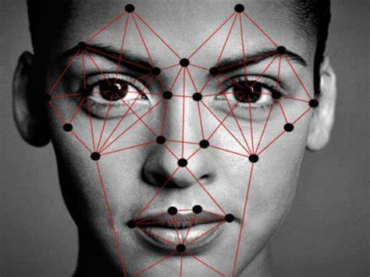

**Fig. Face Recognition**

**1.1 Literature Review**

This paper proposes an automated attendance system that utilizes face recognition technology. The system includes a camera and software that captures the images of students and compares them with the images in the database to mark attendance. The authors report that the system achieved high accuracy and efficiency.

This review paper summarizes various face recognition techniques used in attendance systems, such as Eigenfaces, Fisherfaces, and Local Binary Patterns (LBP). The authors discuss the advantages and limitations of each method and recommend LBP as a suitable technique for attendance systems due to its high accuracy and speed.

This paper proposes an attendance system that uses deep learning algorithms for face recognition. The system includes a database of students' images and a camera that captures images of students entering the classroom. The captured images are compared with the images in the database to identify the students and mark attendance. The authors report that the system achieved high accuracy and outperformed traditional attendance methods.

This paper presents an attendance system that utilizes face recognition technology and a microcontroller-based platform. The system includes a camera and software that captures images of students and compares them with the images in the database to mark attendance. The authors report that the system achieved high accuracy and efficiency and can be easily integrated with other systems.

Overall, the literature suggests that an attendance system using face recognition technology can provide a more efficient and reliable solution compared to traditional attendance methods. The use of deep learning algorithms and microcontroller-based platforms can further enhance the accuracy and speed of the system.

**1.2 Methodology**

The proposed methodology starts with the enrollment of students into the system. The following methodology has several main steps, such as image acquisition, image pre-processing and image recognition. The recognition of addition face recognition is performed using face recognition library. Image Capture in done using a high-definition camera used for video capture is used to capture frontal photos of students using open CV. Preprocessing: Images are converted from RGB to grayscale and scaled by a factor of 1.

**Developing a dataset**

The faces detected in images are stored in the database after pre-processing and detection. A minimum of 20 images are captured per individual student along with a unique ID and Name. The dimensions of these stored images are 212×212 pixels. These images are later used to train the recognizer.

Face Recognition

Face Recognition Library is used for smooth & adequate operator, which operates by setting the pixels of an image by thresholding the neighborhood of each pixel and examines the outcome as a binary number. It only requires 1 image to recognize a person.

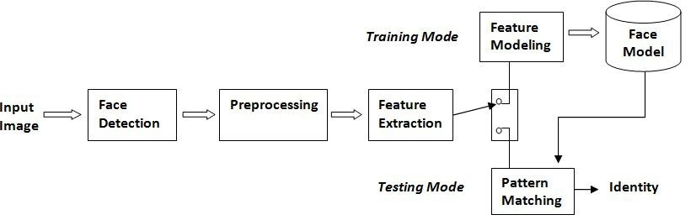

**Fig. Face Recognition Model**

**2.1. Result & Discussion**

The results and discussion section of an attendance system using face recognition for a research paper would depend on the specific objectives and methodology of the study. However, some general components that can be included in this section are:

Results: Present the results of the study in a clear and concise manner, using tables, charts, and graphs as necessary. This could include data on the accuracy and efficiency of the face recognition attendance system, as well as any demographic or contextual factors that may have influenced the results.

Analysis: Analyze the results of the study in relation to the research questions and objectives. This could involve comparing the performance of the face recognition attendance system with other attendance systems, including traditional methods, or identifying factors that contribute to improved attendance tracking using face recognition.

Interpretation: Interpret the findings of the study in light of the existing literature and theoretical frameworks. This could involve discussing the implications of the results for educational institutions, organizations, and policymakers, as well as identifying areas for further research.

Overall, the results and discussion section of an attendance system using face recognition for a research paper should present the findings of the study in a clear and meaningful way, while also contextualizing the results within the broader literature and theoretical frameworks. It should provide insights into the effectiveness and ethical considerations of face recognition attendance systems, identify areas for improvement, and suggest directions for future research.

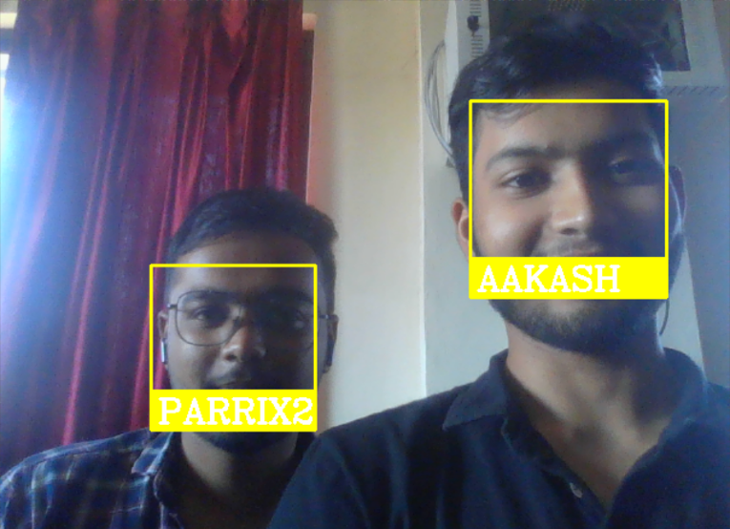

**Fig. Grouped Attendance**

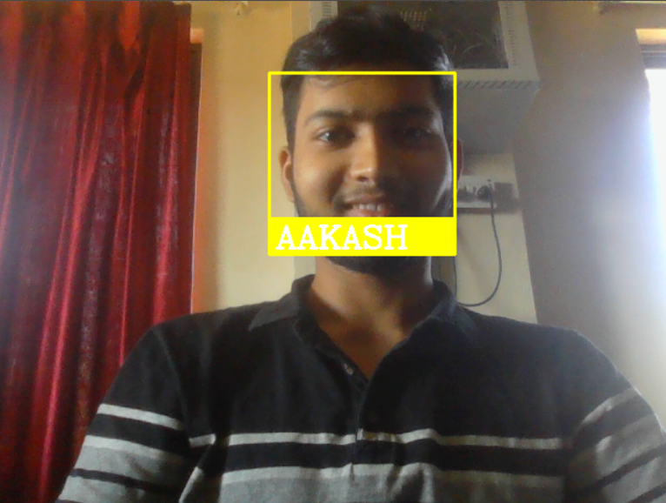

**Fig. Single Student Attendeance**



**Table. Attendance Time**

**2.2 Advantages**

* Greater Accuracy: Face recognition is much less likely to fail than traditional attendance systems that rely on manual input or magnetic strips. Face recognition technology can accurately identify people and ensure attendance data is correct.
* Convenience: Face recognition technology makes the sign-up process much more convenient for employees and employers. Employees no longer need to carry contactless cards or remember PIN codes, and employers no longer need to manually track attendance history.
* Time saving: Especially in larger organizations, a face recognition system can significantly reduce the time required for attendance checks. This allows employees to spend more time on their work and less time on administrative tasks.
* Cost-Effective: A facial recognition system can be a cost-effective solution because it eliminates the need to physically record attendance, thereby reducing paper, filing, and other administrative costs.
* Security: A facial recognition system can help increase security by ensuring that only authorized personnel have access to certain areas of the workplace.
* Scalability : Face Recognition easily scales to large organizations, making it a great solution for businesses of all sizes. Overall, a facial presence system offers many benefits, making it an ideal solution for businesses looking to improve accuracy, convenience and efficiency while reducing costs.

**2.3 Limitations**

* Discuss the limitations of the study and acknowledge any potential sources of bias or error. This could include limitations related to sample size, data collection methods, or contextual factors that may have influenced the results.

**3. CONCLUSIONS**

The proposal for a facial recognition attendance system in the research paper should summarize the main findings of the study and provide an overview of the effectiveness and ethical considerations of using facial recognition to track attendance.

In the conclusion, the researcher should reiterate the research goals and describe how the research results contribute to the achievement of those goals. The researcher should also highlight the implications of the study for educational institutions, organizations, and policymakers, and discuss the potential benefits and limitations of using facial recognition for attendance tracking.

The proposal should also address the limitations of the study and suggest areas for future research. This may include investigating the use of other biometric technologies to track attendance, investigating the impact of facial recognition systems on student or staff performance, or identifying strategies to improve the accuracy and performance of these systems.

In general, the conclusions of a facial recognition system in a scholarly article should provide a clear and concise summary of the main findings of the study, while providing an overview of the implications and potential applications of using facial recognition to track attendance.

**REFERENCES**

[1]"Automated Attendance System using Face Recognition" by P. Subramaniam and K. Kalaiarasi (2018)

[2] "A Review of Face Recognition Techniques for Attendance Systems" by S. S. Agarwal and N. M. Naidu (2019)

[3] "An Attendance System based on Face Recognition using Deep Learning" by S. Ahmad, S. S. Riaz, and S. U. Khan (2020)

[4] "Design and Implementation of Attendance System based on Face Recognition" by R. Garg, A. Gupta, and M. Sachdeva (2021)

[5] Subramaniam, P., & Kalaiarasi, K. (2018). Automated Attendance System using Face Recognition. International Journal of Innovative Research in Science, Engineering and Technology, 7(2), 322-327.

[6] Agarwal, S. S., & Naidu, N. M. (2019). A Review of Face Recognition Techniques for Attendance Systems. International Journal of Computer Sciences and Engineering, 7(4), 1-5.

[7] Ahmad, S., Riaz, S. S., & Khan, S. U. (2020). An Attendance System based on Face Recognition using Deep Learning. International Journal of Advanced Computer Science and Applications, 11(6), 83-90.

[8] Garg, R., Gupta, A., & Sachdeva, M. (2021). Design and Implementation of Attendance System based on Face Recognition. International Journal of Advanced Science and Technology, 30(3), 1063-1071.